

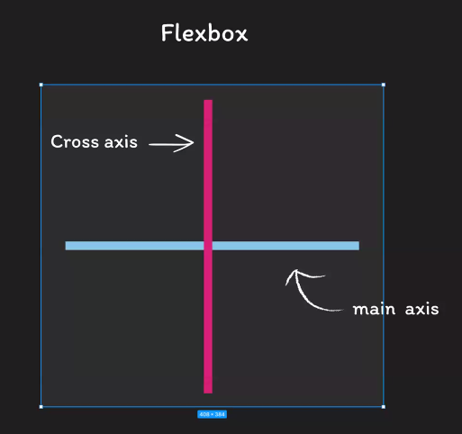

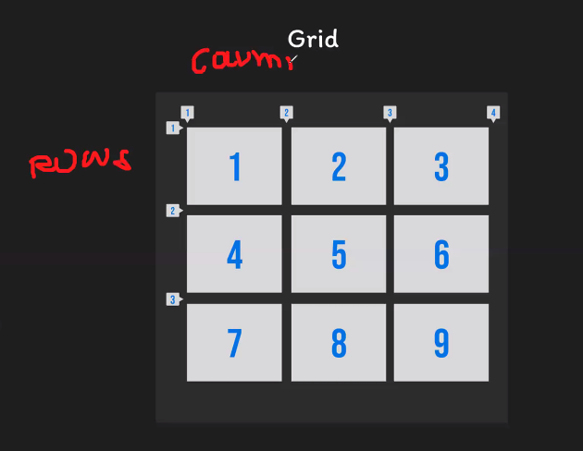

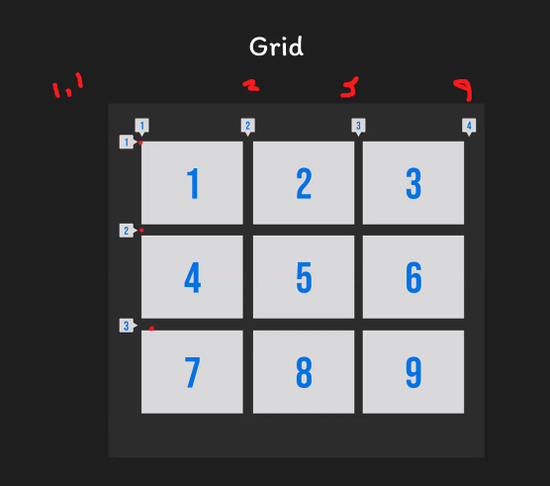

/\* Using gap \*/  
.gridContainer {  
    display: grid;  
    gap: 10px;  
    gap: 0px;  
    grid-column-gap: 20px;// idk why nay strikethrough akong grid-column-gap and the grid-row-gap  
    grid-row-gap: 10px;  
    gap: 0px;  
}

